EET 315- POWER GENERATION, TRANSMISSION AND IDSTRIBUTION SYSTEM

Name:

BEET 3C

1.

➢ Explain the very concept on how important Electricity Generation in present

situation.

1. The energy sources include renewable energy and nonrenewable energy resources. Renewable energy sources being those energy flows that occur naturally and repeatedly in the environment can be harnessed for human benefit including power generation. The ultimate sources of most of these energies are the sun, gravity, and the earth’s rotation. Non renewable energy sources are those which are obtained from static stores of energy that remain bound unless released by human interaction. These include nuclear fuels and fossil fuels; coal, oil and natural gas etc.

➢ Make research of the following:

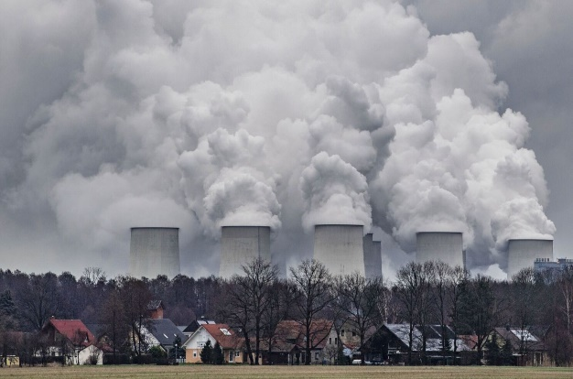• Coal Fired Power Plants

* Coal-fired plants produce electricity by burning coal in a boiler to produce steam. The steam produced, under tremendous pressure, flows into a turbine, which spins a generator to create electricity. The steam is then cooled, condensed back into water and returned to the boiler to start the process over.

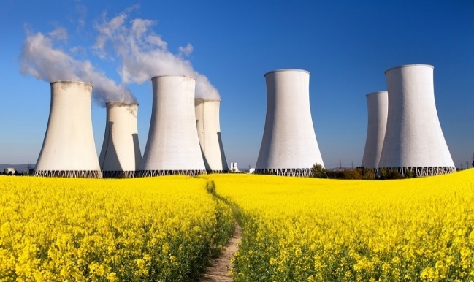• Nuclear Power Plants

* Nuclear power plants heat water to produce steam. The steam is used to spin large turbines that generate electricity. Nuclear power plants use heat produced during nuclear fission to heat water. In nuclear fission, atoms are split apart to form smaller atoms, releasing energy.

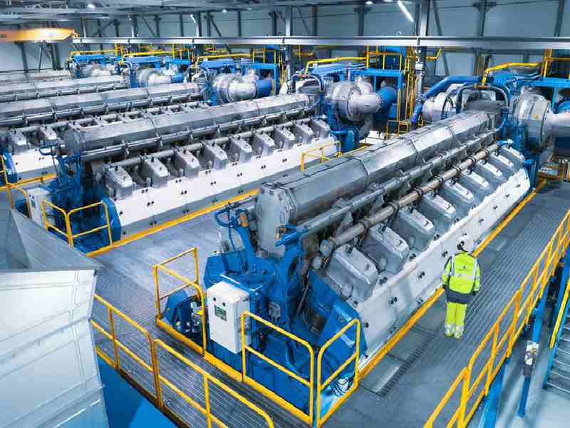• Diesel Fire Power Plants

* Diesel generators convert some of the chemical energy, contained by the diesel fuel, to mechanical energy through combustion. This mechanical energy then rotates a crank to produce electricity. Electric charges are induced in the wire by moving it through a magnetic field.

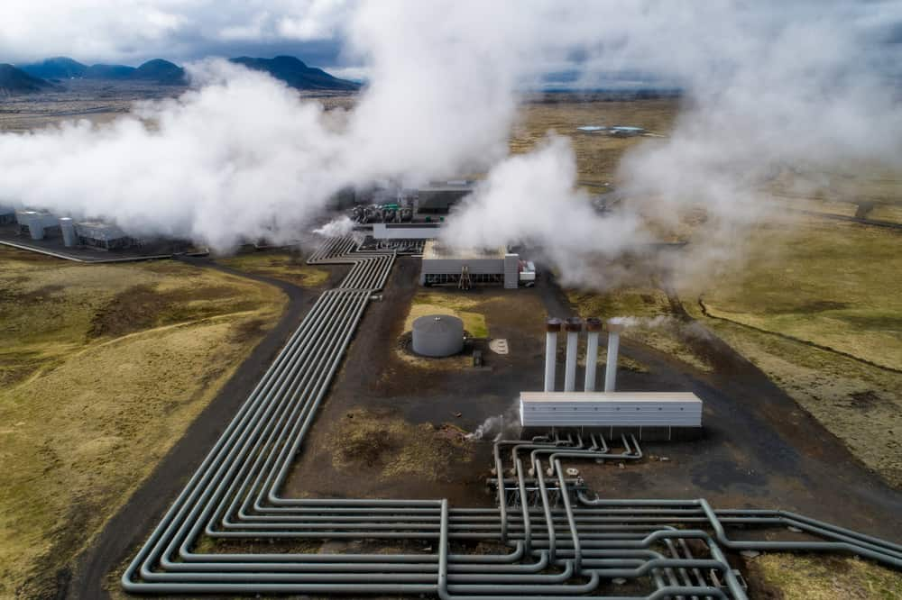• Geothermal Power Plants c

* Geothermal power plants require high-temperature (300°F to 700°F) hydrothermal resources that come from either dry steam wells or from hot water wells. People use these resources by drilling wells into the earth and then piping steam or hot water to the surface.

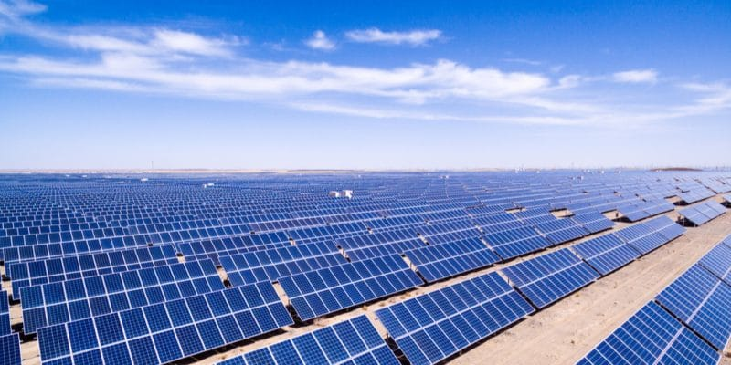• Solar Power

* Solar power is the conversion of renewable energy from sunlight into electricity, either directly using photovoltaics, indirectly using concentrated solar power, or a combination. Concentrated solar power systems use lenses or mirrors and solar tracking systems to focus a large area of sunlight into a small beam.

In each of this power plants, describe their applications, how it produces

electricity, and how could affect the environment.

(Show pictures, and other needed important details upon describing each of

these power plants)

2.

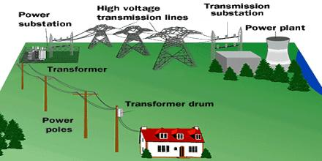➢ What is Power Distribution System and how it is important?

* Power distribution system means the portion of an electricity grid owned or operated by a utility that is dedicated to delivering electric energy to customers. The bigger the power demand, the greater potential there is for wastage, which means that optimizing energy consumption is always a central concern. Maintaining this efficiency is also important to the integrity of the equipment.

➢ Describe the following:

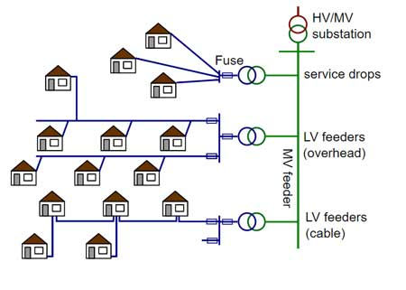• Distribution Feeders

* Distribution feeder or “feeder” means a three-phase set of conductors emanating from a substation circuit breaker serving customers in a defined local distribution area. This includes three-phase, two-phase and single-phase branches that are normally isolated at all endpoints.

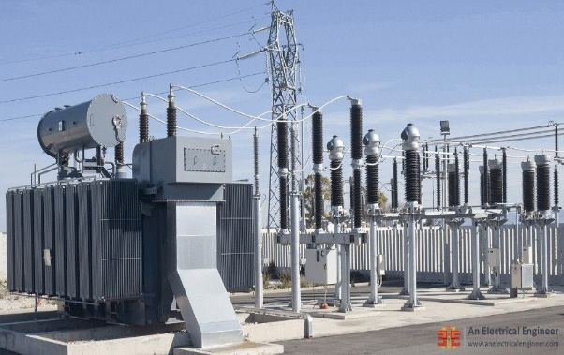• Distribution Substation

* A distribution substation transfers power from the transmission system to the distribution system of an area. The input for a distribution substation is typically at least two transmission or sub transmission lines.

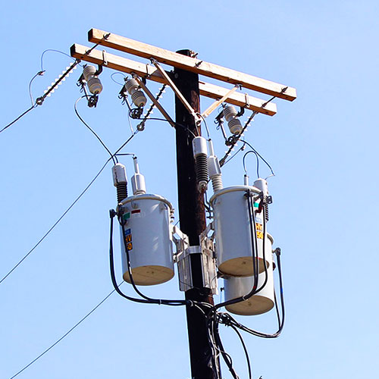• Distribution Transformers

* A distribution transformer is the type of transformer that performs the last voltage transformation in a distribution grid. It converts the voltage used in the transmission lines to one suitable for household and commercial use, typically down to 240 volts.

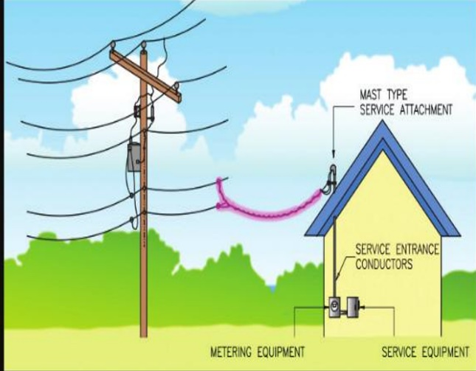• Service Conductors

- Service conductors is a broad term and may include service drops, service laterals, and service-entrance conductors. This term specifically excludes, however, any wiring on the supply side (serving utility side) of the service point.

(Show pictures, and other needed important details upon describing each of

these)